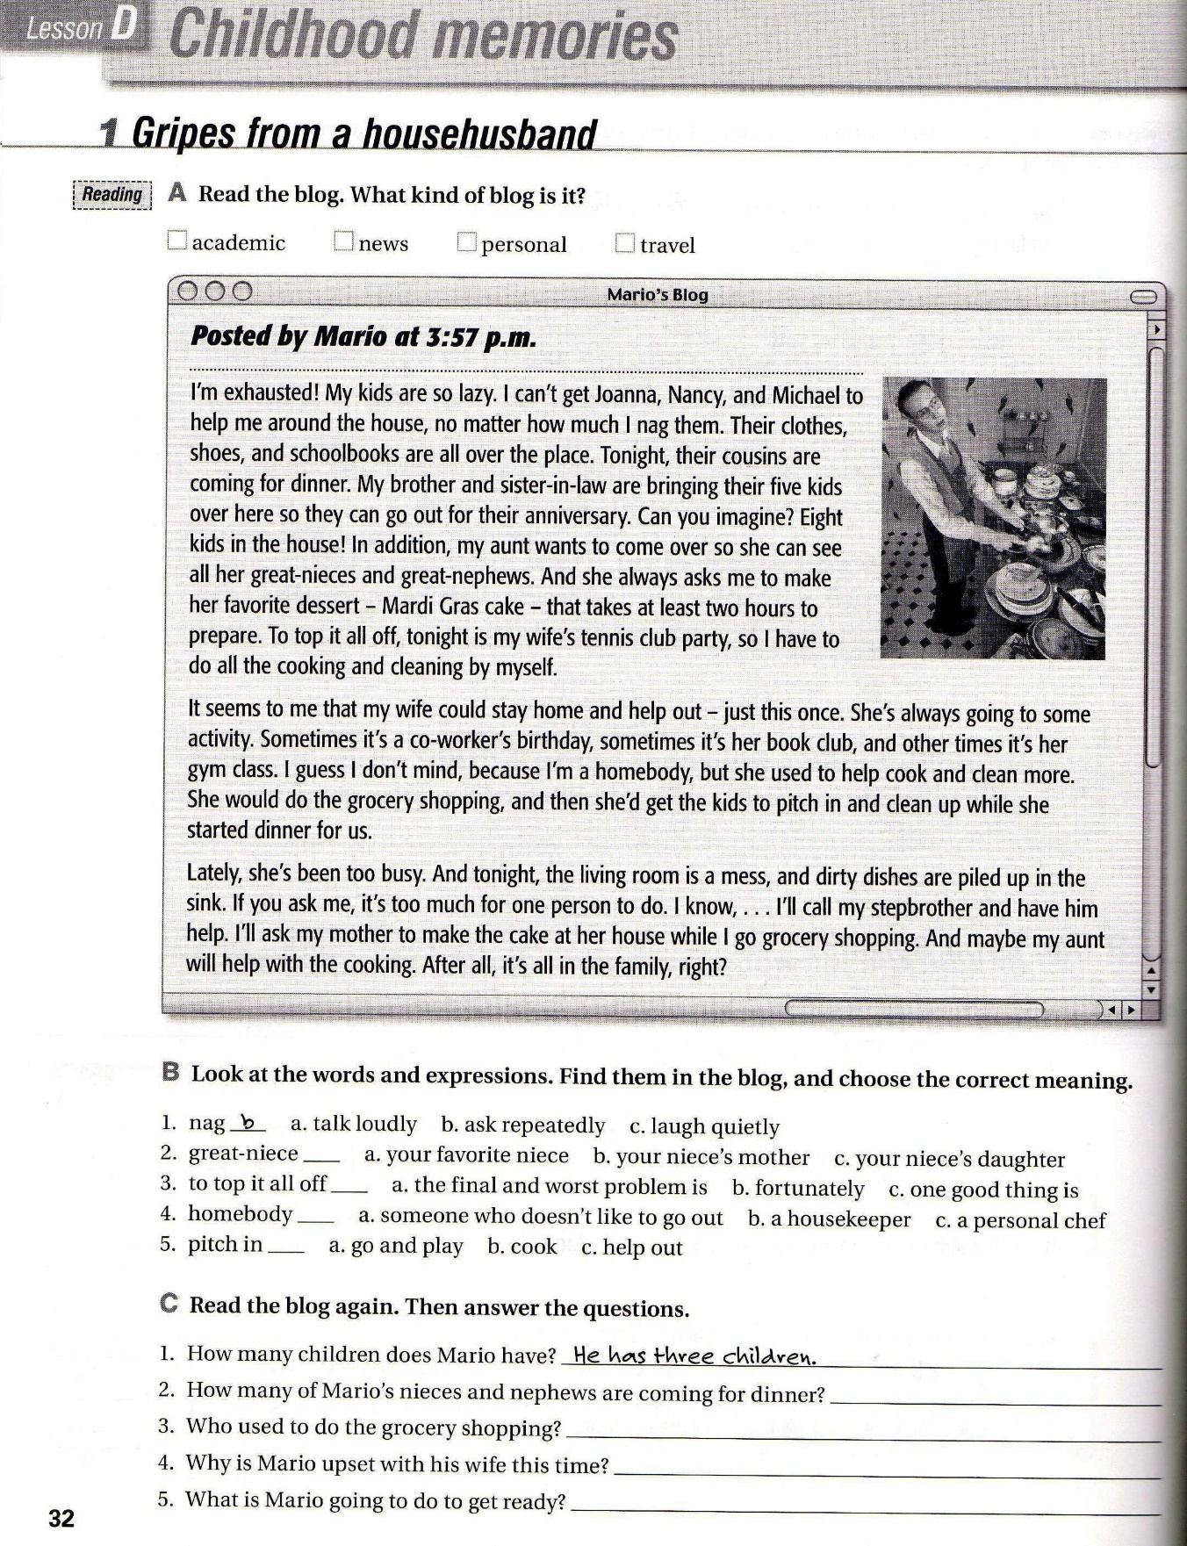

He is going to go grocery shopping

She is going to a party so she isnt to helping him with the clenaing and cooking

His wife used to do the grocery shopping

Find of them are coming for dinner

c

a

a

c